Enabling IIS Search in WebWorks Reverb
David Shaked
Revised 17/01/2012 for WebWorks 2011.3 and Windows 7
Copyright © 2012 AlmondWeb Ltd. All rights reserved.

Overview 1
Installing IIS 1
Generating the Reverb Output 2
Enabling Windows Search and Indexing 3
Configuring an IIS Application 7
Testing the Output on IIS 7
References and Credits 8

Overview
You can integrate a WebWorks Reverb project with one of three search engines:
Google Site Search
This option is recommended if you deploy the Reverb output to a public website. Google Site Search provides powerful Google search capabilities in the scope of the site.
Microsoft Internet Information Services (IIS) search
This option is recommended if you deploy Reverb on an IIS web server that is behind a firewall or protected by a password. IIS uses Windows Search logic to find topics within the Reverb output.
Internal Reverb client-side search
This option is recommended if you deploy Reverb on a web server other than IIS, behind a firewall or protected by a password.
This article explains how to enable the IIS search. As part of the explanation, the article explains how to deploy Reverb on IIS.
The article assumes that you use IIS 7.5 on a Microsoft Windows 7 host. For other IIS and Windows versions, you might need to modify the instructions.

Installing IIS
If IIS is not installed on the computer, you must install it. You must enable the World Wide Web Services, ASPX, and the management tools. Other IIS features might be necessary depending on your application.
- If you are not an experienced web-server administrator, consult an administrator about security issues before installing or configuring IIS or any other web server.
- Log on as an administrator of the local computer.
- On the Windows 7 host, open Control Panel > Programs > Turn Windows Features On and Off.
- Select the Internet Information Services entries.

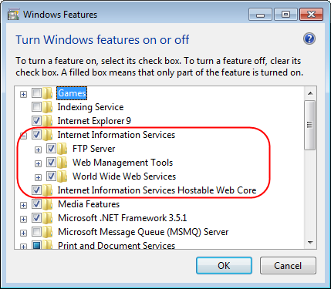

Generating the Reverb Output
- In a WebWorks ePublisher (WWeP) project, configure a WebWorks Reverb target.
- In the Target Settings, set the WebWorks Reverb/Search Implementation option to Microsoft IIS Search.

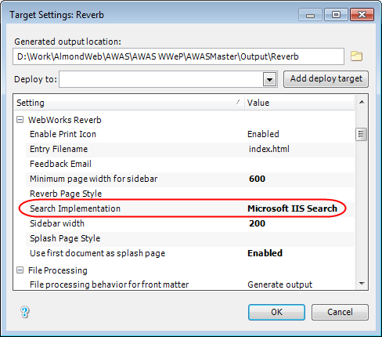

- Configure the other project options and generate the output.
- Test the output on the built-in WebWorks mini-web server.
The IIS search does not work on the built-in web server.

Enabling Windows Search and Indexing
The IIS search requires the Windows search and indexing features. To configure these features, perform the following steps.
- Log on as an administrator of the local computer.
- Copy the Reverb output directory to a location on the IIS web server.
If you are uncertain of the correct location, ask the IIS administrator.
If the IIS web server can access the directory where you generated the output, this step is optional. In the subsequent steps, you can define the virtual directory to point directly to the Reverb output directory.
- On the IIS host, open Control Panel > Programs > Turn Windows Features On and Off.
- Verify that the Windows Search feature is enabled.

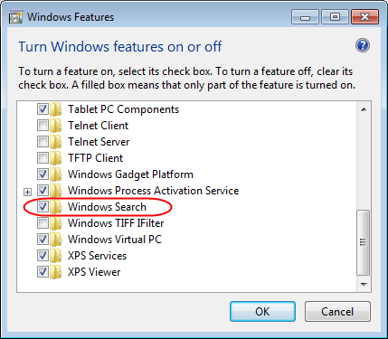

- Open the Start menu. In the search box, enter the word search.

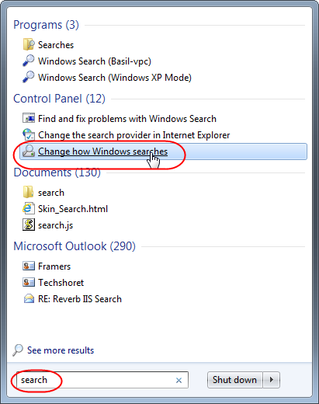

- In the Control Panel option, click Change How Windows Searches.
This opens the Indexing Options.

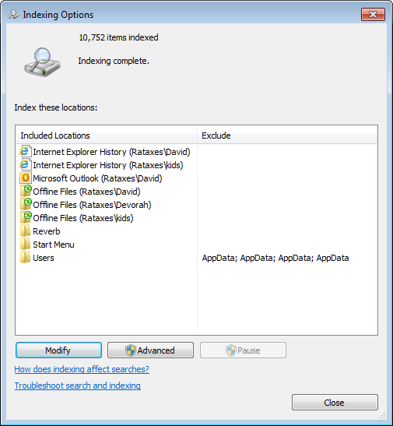

- Confirm that the location where you stored the Reverb output is indexed. If it does not appear in the list of Included Locations, click the Modify button and add it.

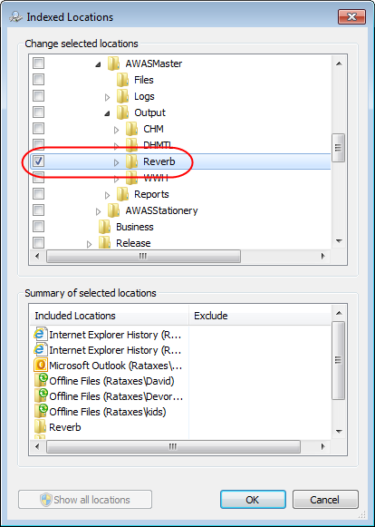

- Wait until indexing is complete. Depending on the size of the directory that you added, this might take from minutes to hours.

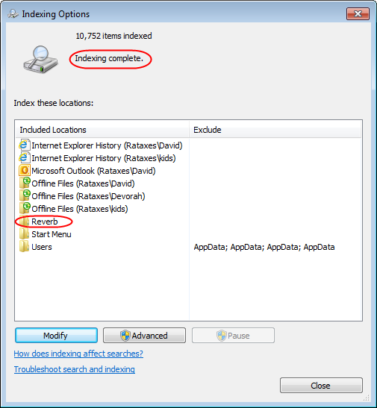

Configuring an IIS Application
You must configure the Reverb output as an IIS application that a user can access via a URL.
- Log on as an administrator of the local computer.
- On the IIS host, open Control Panel > System and Security > Administrative Tools > Internet Information Services (IIS) Manager.
- In the left pane, right-click the website name (usually Default Web Site), and click Add Virtual Directory.
- Set the following options:
Alias
The virtual directory name, for example, ReverbTest.
Physical path
Browse to the physical path where you stored the Reverb output. This must be a location where you enabled indexing.
- Right-click the new virtual directory, and click Convert to Application.

Testing the Output on IIS
To test the Reverb output on the IIS web server:
- Open a web browser.
- Browse to the URL of the virtual directory that you have configured. For example, if you are testing on the host where IIS is installed, browse to:
http://localhost/ReverbTest
The Reverb output is displayed.
- Switch to the search tab, and search for a term that you know appears in the help topics.
The search results are displayed.

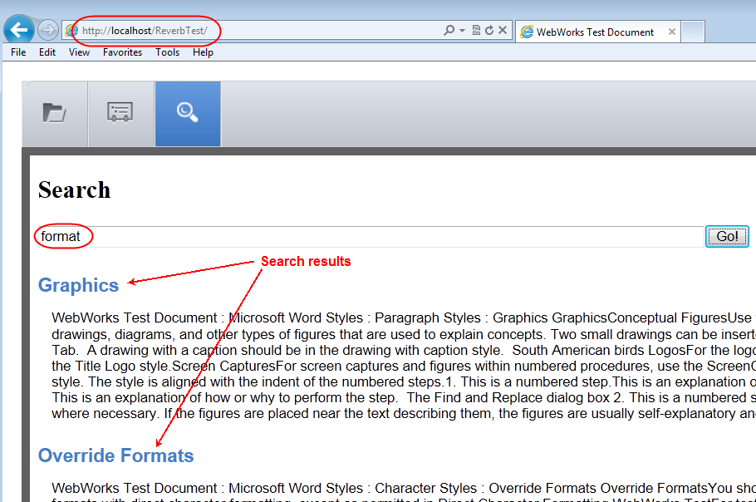

References and Credits
Credit
The procedures described in this article were developed by the WebWorks R&D team, headed by Ben Allums. This article results from a collaboration between Ben and the author to work out the precise procedures on the author's system.
Windows Indexing Options
http://windows.microsoft.com/en-US/windows7/Improve-Windows-searches-using-the-index-frequently-asked-questions
http://helpdeskgeek.com/windows-7/windows-7-file-search-indexing-options/
Potentially updated information about configuring Reverb IIS server
http://wiki.webworks.com/Permalinks/Solutions/Output/WebWorksReverb/
ConfiguringIIS/ConfiguringSearch/

